GUARDED SECRETS
Mélyen örzött titkok
Gut gehütete Geheimnisse
Irma Varró is 18-years when she leaves the orphanage.
All she knows about her past is that she was abandoned at birth. She knows only a few sure, hard facts about her life. She is pregnant.
She has just got the first opportunity in her life: a job as a cleaning woman. And she has made the "best deal" of her life: she will sell her unborn baby abroad with the help of a child-dealer.
But who is she? Who was her mother? She begins to search for her mother whom she has never met, because she wants to pay her back for the grievances she has suffered.
During her investigation Irma finds out that nothing is true of what she thought she knew. She is not who she believed herself to be.
Everything is shrouded by mystery and secrets...
© BGB-Film, Wega-Film, Delor, 2004
35mm, colour, 1:1,85, 89 min
Contact: bgb@axelero.hu

Cast
LILIRMA: |  | Eszter Bagaméri
IRMA: |  | Anna Györgyi
SZILVIA: |  | Andrea Fullajtár
DR. MÁRTON: |  | Dezsö Garas
KATINKA: |  | Kati Outinen
ALEX: |  | Peter Franzén
JÓZSI: |  | Ervin Nagy

Crew
Director: |  | Zsuzsa Böszörményi
Director of photography: |  | Márton Miklauziè
Music composer: |  | Ferenc Darvas
Set designer: |  | Zsolt Khell
Costume designer: |  | Fruzsina Nagy
Editor: |  | Gabriella Koncz
Sound engineer: |  | Csáki János
Line producer |  | Andrea Kormos

 |  | Production
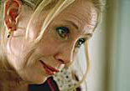
  Production companies: |  | BGB FILM (Hungary) – WEGA-FILM (Austria) – DELOR (Finland)
  Producers: |  | Livia Gyarmathy  Veit Heiduschka  Hanna Hemilä

Mit der Unterstützung von





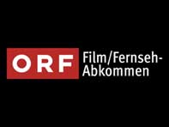



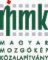

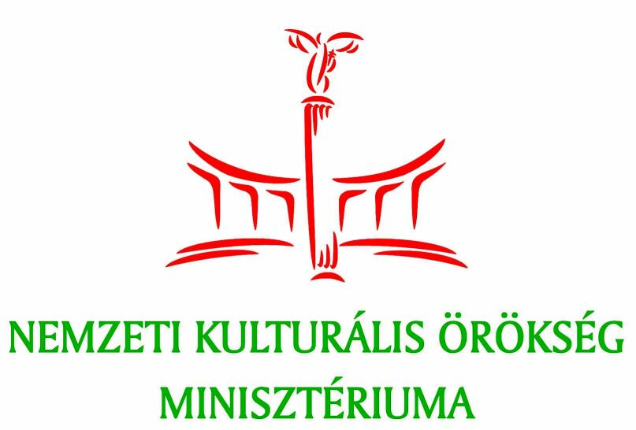











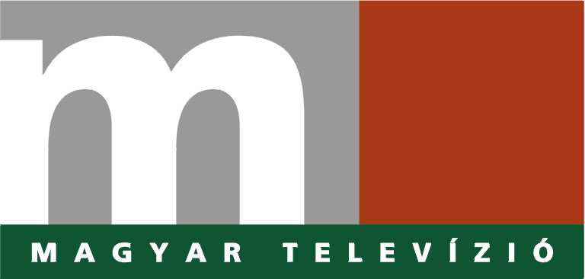



Szociális-és Családügyi Ministerium

Cinema Filmrendezö Alapítavány - NKA

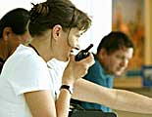 |  | Zsuzsa Böszörményi

Filmography
As director:
GUARDED SECRETS (director, feature film, 2004)
Hungarian – Austrian- Finnish co-production with Eurimages support
Prizes: |  | Best director – BUDAPEST, National Film Festival 2004  Best actress – BUDAPEST, National Film Festival 2004  Best actor in supporting role – BUDAPEST, National Film Festival 2004  Best production company – BUDAPEST, National Film Festival 2004
RED COLIBRI (director, feature film, 1995)
Italian - Hungarian co-production
Prizes: |  | Special Prize of the Jury for the best european film - OURENSE, 1996  Best Leading Actress - SALERNO, 1996  Prize for the Film - SALERNO, 1996  „Lumiére-Prize" For the Best First Film - CALCUTTA, 1996
ONCE UPON A TIME (director, short film, 1991)
Prizes: |  | STUDENT ACADEMY AWARD FOR THE HONORARY FOREIGN FILM –  Academy of Motion Picture Arts and Sciences - LOS ANGELES, 1991  Best Documentary - LONDON, 1992  Special Prize of the Swiss Television - NYON, 1991  Special Prize of the Hungarian Filmcritics - BUDAPEST, 1992  GRAND PRIX – ISMAILIA, 1991  FIPRESCI- Prize - ISMAILIA, 1991
BIHARSAROK (director, full length documentary, 1989) with Klára Péter
MOSAICS ABOUT FEMALE ALCOHOLISM (director, short film, 1988)
OH, CAROL! (director, short film, 1987)
Prize: |  | Special Prize of „Filmfest" - BUDAPEST, 1988
As a producer:
BALLROOM DANCING (producer, documentary, 2003)
Directed by Lívia Gyarmathy
Prizes: |  | Best director - Wiesbaden, 2003  „Silver Dragon” – Krakkow, 2003  Prize of the Youth Jury – Krakkow, 2003  Honorary mention – Montreal, 2003
OUR STORK (producer, short film, 1999)
Directed by Lívia Gyarmathy
Prizes: |  | EUROPEAN FILM AWARD FOR THE BEST EUROPEAN SHORT FILM  2000 – Prix UIP  SUR LE DOC, „Planete”- Grand Prix – MARSEILLE, 1999  GOLDEN SPIRE Prize – SAN FRANCISCO, 2000  National Film Festival: Special Prize of the Jury – BUDAPEST, 1999  Best documentary – ANTALYA, 1999  Prize of the city of Antaly – ANTALYA, 1999  Best documentary – BUKAREST, 1999
ESCAPE (producer, feature film, 1997)
Hungarian – German – Polish co-production with Eurimages support
Directed by Lívia Gyarmathy
Prizes: |  | National Film Festival: Prize For the Best Screenplay – BUDAPEST, 1997  Best Director - ISTAMBUL 1999
Personal awards and recognitions
2000 - Member of the European Film Academy
1991 - The Academy of Motion Picture Arts and Sciences of Los Angeles - STUDENT ACADEMY AWARD FOR THE HONORARY FOREIGN FILM
Other activities
1997 - Member of the Board of „FILMJUS”, Hungarian Society for the Protection of Audio-Visual Authors’ and Producers’ Rights
2001 - Member of the Board of the Filmjus’ Film Fond

BGB FILM LTD
1126 Budapest, Böszörményi út 3/a, Hungary
Tel/fax: +361 315 0596, +361 212 6172 Mobile: +36 20 9433250
e-mail: bgb@axelero.hu
GUARDED SECRETS (MÉLYEN ÖRZÖTT TITKOK) - feature film, 2004
Hungarian – Austrian – Finnish co-production with Eurimages support
director: |  | Zsuzsa Böszörményi
script: |  | Géza Böszörményi and Zsuzsa Böszörményi
producer: |  | Lívia Gyarmathy, Veit Heiduschka, Hanna Hemilä
Prizes: |  | Budapest Hungarian Film Week 2004 :  Best Actress: Eszter Bagaméri,  Best Supporting Actor: Ervin Nagy,  Best Producer: BGB FILM
BALLROOM DANCING (TÁNCREND) – documentary, 2003
director: |  | Lívia Gyarmathy
producer: |  | Zsuzsa Böszörményi
Prizes: |  | Wiesbaden GoEast Film Festival 2003:  Best Director  Cracow International Documentary & Short Film Festival 2003:  Silver Dragon  Students Jury's Prize for the Best Film of the International Competition, Cracow 2003  Montreal International Festival New Cinema New Media 2003  Special Mention
OUR STORK (A MI GÓLYÁNK) - documentary, 1999
director: |  | Lívia Gyarmathy
producer: |  | Zsuzsa Böszörményi
Prizes: |  | EUROPEAN FILM AWARD FOR THE BEST EUROPEAN SHORT FILM 2000  SUR LE DOC, „Planete”- Grand Prix – MARSEILLE, 1999  GOLDEN SPIRE Prize – SAN FRANCISCO, 2000  National Film Festival: Special Prize of the Jury – BUDAPEST, 1999  Best documentary – ANTALYA, 1999  Prize of the city of Antaly – ANTALYA, 1999  Best documentary – BUKAREST, 1999
ESCAPE ( SZÖKÉS) - feature film, 1997
director: |  | Lívia Gyarmathy
script: |  | Géza Böszörményi
producer: |  | Zsuzsa Böszörményi
 |  | Presentations and festival partecipations: Washington, London, Cairo, Göteborg, Amsterdam, Istanbul
Prizes: |  | National Film Festival: Prize For the Best Screenplay – BUDAPEST, 1997  Best Director - ISTANBUL 1999

Awards
Prizes:
- Best director BUDAPEST,
National Film Festival 2004
- Best leading actress (Eszter Bagaméri) BUDAPEST,
National Film Festival 2004
- Best actor in supporting role (Ervin Nagy) BUDAPEST,
National Film Festival 2004
- Best production company BUDAPEST, National Film Festival
2004

